

הפקולטה להנדסה

הצעת מחקר לתואר שני

**הנושא:**

**<כותרת המחקר בעברית>**

**<Research Title>**

שם המנחה: <שם המנחה>

<שם המגיש> <תעודת זהות>

Table of Contents

Chapter 1: Introduction 4

Chapter 2: Background 5

Chapter 3: Research Objectives and Methodology 6

Chapter 4: Preliminary Results 7

Abstract

*The abstract for a thesis or research proposal is much more extensive than the short abstract for an article. It should be approximately 1 page long and really be an executive summary of the proposal, including some background, presenting the problem, and explaining how you propose to address it. Don’t forget to point out your*

*achievements, such as the number of papers that you published.*

# 

# Introduction

*This is the introduction chapter. The introduction is generally an “executive summary”*

*of the thesis, providing some motivation, short overview of state-of-the-art, introduction of the solution presented in the thesis, and some results. It then usually will introduce the structure of the thesis (i.e., the content of each chapter). Make sure to (yet again) point out your achievements, such as papers that have already been published or are in submission.*

# Background

*This is the background chapter. The background chapter should be a very extensive literature survey, covering the main concepts that lead to the presented work and then a detailed overview of the state-of-the-art. Make sure to cover all seminal works that are related to your work and all recent publications. If possible, try to point out limitations or drawbacks of prior art that has led to the work that you are presenting in this thesis.*

*Here is an example of how to include a figure in your thesis. Make sure to reference each and every figure using MSWord’s CROSS REFERENCE feature (e.g.,* see Figure ‎2.1Figure ‎2.1 *) and to provide a sufficient description of the figure contents in both the text and the figure caption.*

*To learn how to make article-quality figures with power point, we recommend watching*

*the following tutorial:*

<https://www.youtube.com/playlist?list=PLZU5hLL_713zNceifg18xNroxzeIBdJi0>.

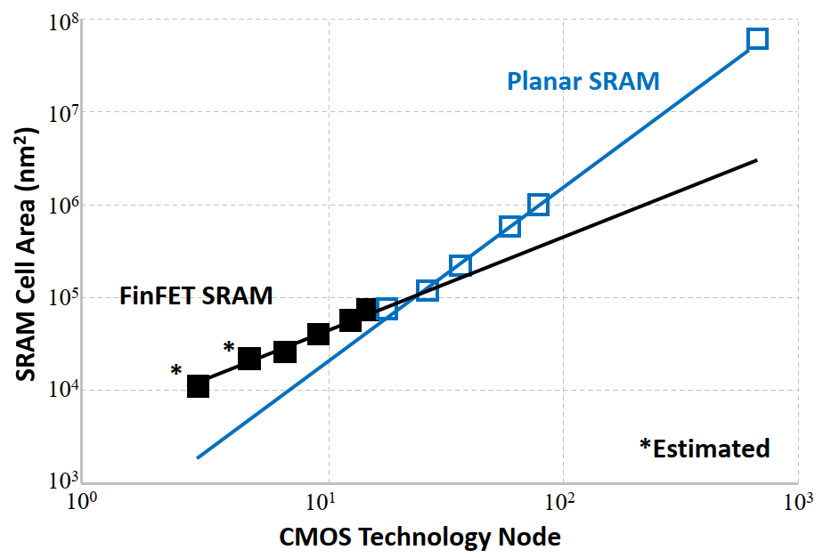

Figure .: My first figure. Use the INSERT CAPTION feature to create the automatically numbered caption

# Research Objectives and Methodology

## Objectives

The main research objective of this work is to…

## Methodology

The methodology for carrying out this research is…

# Preliminary Results

*Optionally, include some preliminary results.*

*Similar to Figures, you should also reference every Table that you include in the thesis and do this using the CROSS REFERENCE features (e.g.,* see Table ‎4.1*). For a very good tutorial on how to make professional looking tables, see the following presentation:* <https://people.inf.ethz.ch/markusp/teaching/guides/guide-tables.pdf>

|  |  |  |  |
| --- | --- | --- | --- |
| sdfs | First work | Second work | Third work |
| First metric | 100 | 100 | 100 |
| Second metric | 200 | 200 | 200 |
| Third metric | 300 | 300 | 300 |

Table .: This is a table caption.

Bibliography